[ZANG] - [Chuanjie]

Student ID: 699382953

[chuanjiezang@gmail.com](mailto:chuanjiezang@gmail.com)

For a basic shopping site, I think there needs to be the basic pages of 'login/register', product shopping, shopping cart, checkout.

1. User Login Flowchart

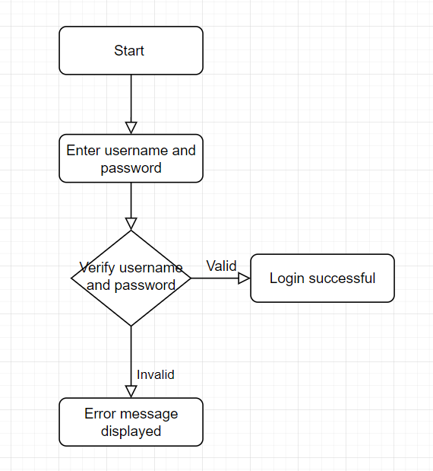

1. User Login Pseudo-Code

START

INPUT username, password

IF validate_credentials(username, password) THEN

DISPLAY "Login successful"

REDIRECT to user_dashboard

ELSE

DISPLAY "Invalid username or password"

END IF

END

In the process of completing the whole shopping site, I have encountered many problems, which I eventually solved. There are still a few details that I haven't had time to perfect in the functionality of the shopping site, including adding 'back' buttons between pages and refining the editing of the products in the shopping cart, etc., but the functionality has been more complete so far.

Because it took so much time to iterate on the code as I completed it, I could only complete this word note after I had completely finished the final project.

SQL：  
I used (localdb)\NewInstance as the server name, instead of the default name

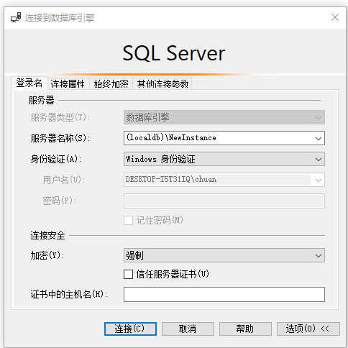

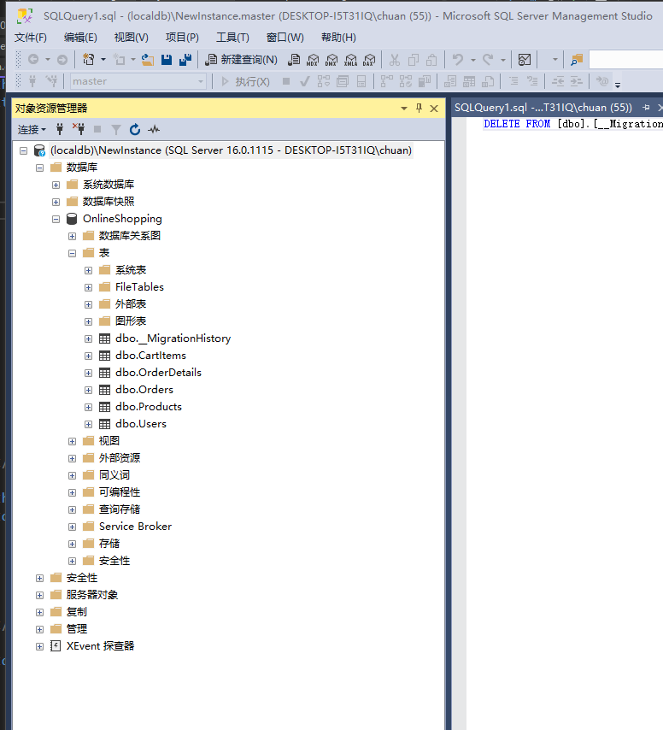

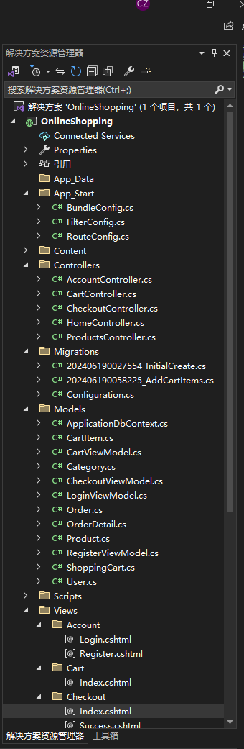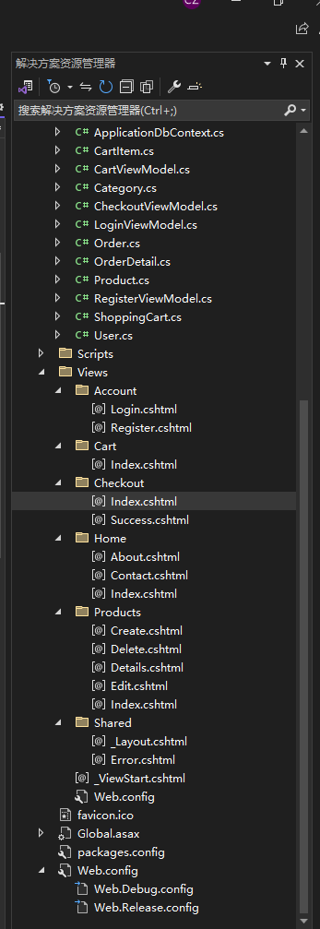

Click ‘OnlineShopping.sln - shortcut’ or open ‘ OlineShopping - OnlineShopping.sln’ to run the website.

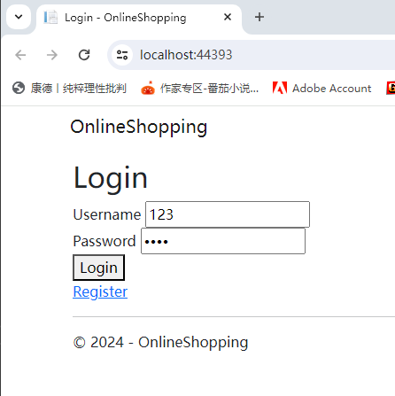

Password:1234

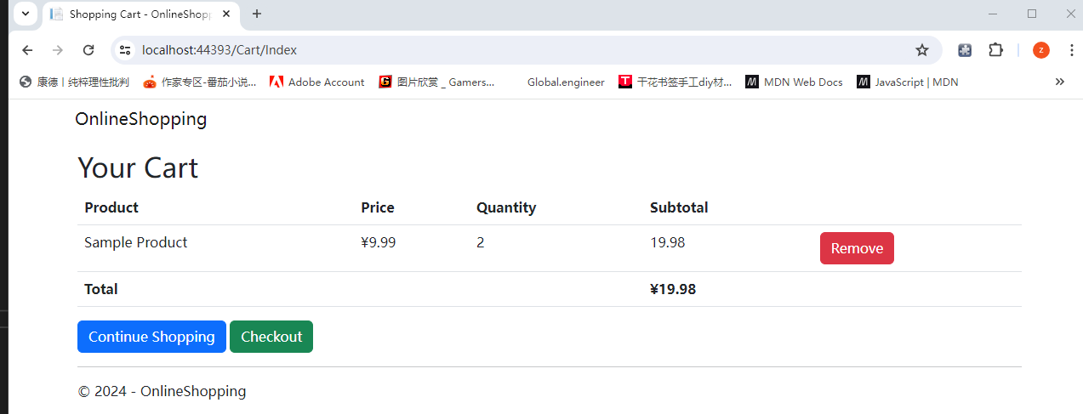

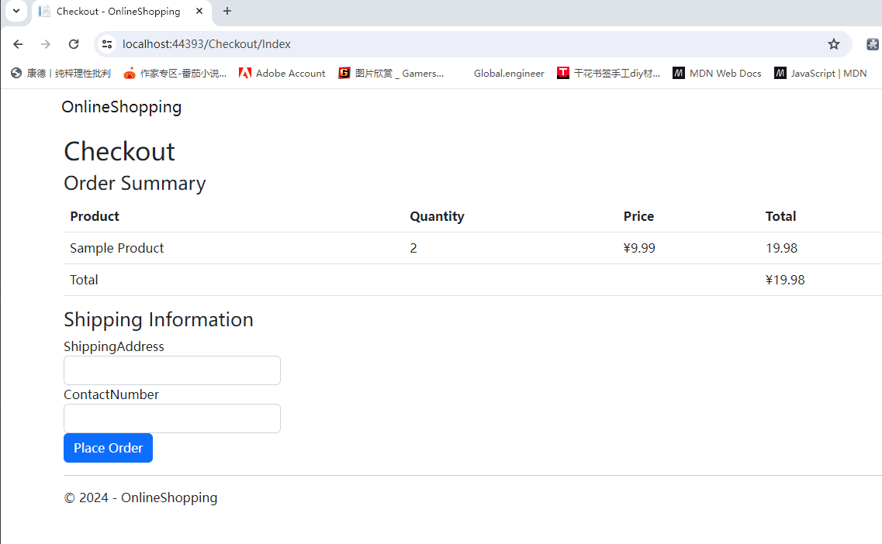

After I copied the local folder and then opened it again this error message appeared, but it was still possible to open the web page by clicking 'Run'.

